

Mathematics Specialist
Unit 4
2017
TEST 5
SOLUTIONS

Student name: _______________________ Teacher name: _______________________

Time allowed for this task: 40 minutes, in class, under test conditions
Calculator-Assumed

Materials required:
Standard items: Pens (blue/black preferred), pencils (including coloured), sharpener, correction fluid/tape, eraser, ruler, highlighters, SCSA Formula Sheet.
Classpad Calculator and Scientific Calculator.
Special items: Drawing instruments, templates

Marks available: 39 marks

Task weighting: 8%

Question 1. (7 marks)

(a) A particle undergoing simple harmonic motion with a period of 5 seconds is observed to move in a straight line, oscillating 3.6 m either side of a central position. Determine the speed of the particle when it is 3 m from the central position. (3 marks)
Solution
$$ω=\frac{2π}{5} \\ v^{2}={\left(\frac{2π}{5}\right)}^{2}\left({3.6}^{2}-3^{2}\right) \\ \left|v\right|=2.50 \text{m/s}$$

Specific behaviours
determines $ω$
substitutes into velocity equation
evaluates speed

(b) Another particle moving in a straight line experiences an acceleration of $x+2.5$ ms⁻², where $x$ is the position of the particle at time $t$ seconds.

Given that when $x=1$, the particle had a velocity of 2 ms⁻¹, determine the velocity of the particle when $x=2$. (4 marks)

Solution
$$\frac{1}{2}v^{2}=\int{x+2.5}dx \\ v^{2}=2\left(\frac{x^{2}}{2}+2.5x\right)+c \\ x=1, v=2⇒c=-2 \\ x=2⇒v^{2}=2\left(\frac{2^{2}}{2}+2.5(2)\right)-2⇒v=±2\sqrt{3}$$

Specific behaviours
uses appropriate form of acceleration
integrates
evaluates constant
states all possible values of v

Question 2. (8 marks)
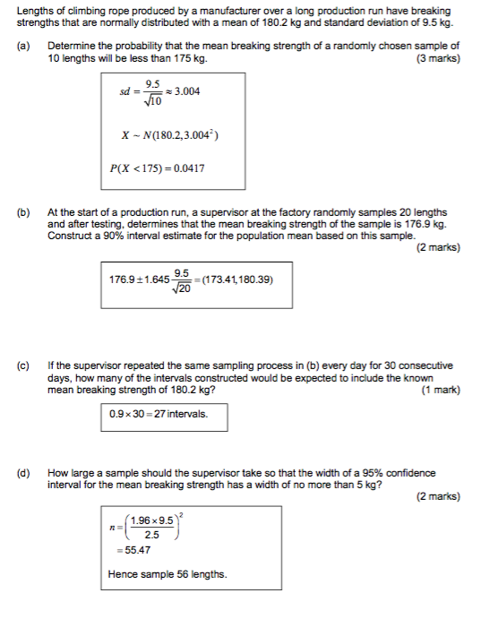

Question 3. (12 marks)
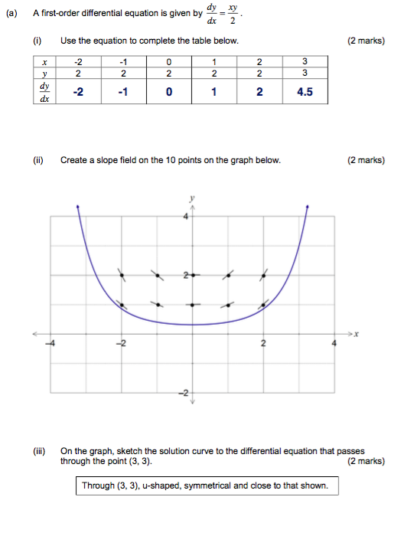
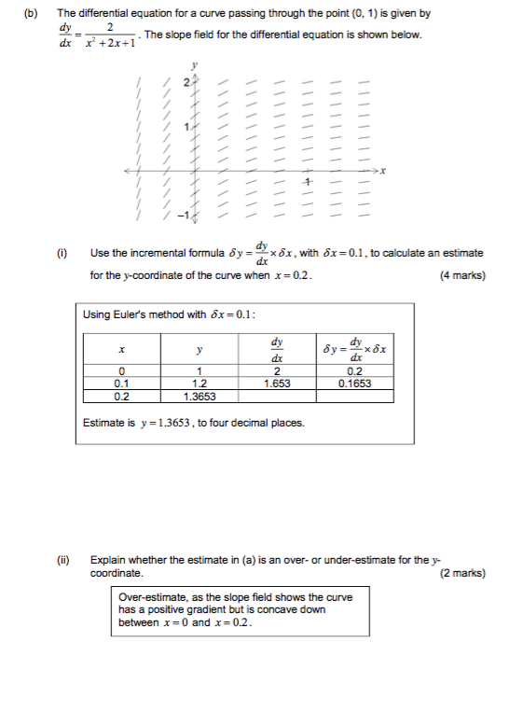

Question 4. (12 marks)

